**Name:** Kanak Agrawal

**Email:** [Kanakagrawal2001@gmail.com](mailto:Kanakagrawal2001@gmail.com)

**Date**: 31-01-2024

**Python Day-3**

**Question: What is JSON?**

**Answer:** JSON stands for JavaScript Object Notation. It means that a script (executable) file which is made of text in a programming language, is used to store and transfer the data.

* **Convert JSON String to Dictionary python**

In this we are going to convert JSON string to python dictionary using json.loads() method of json module.

**Code:** 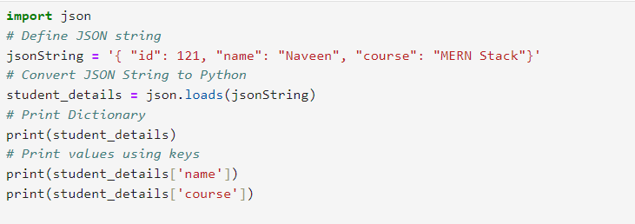

**Output:**

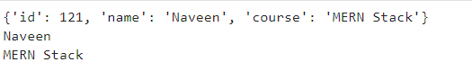

* **Convert JSON file to python object**

**Code:**

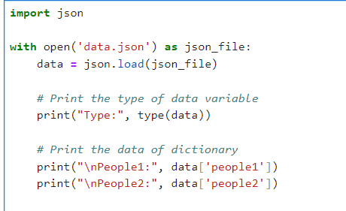

**Output:**

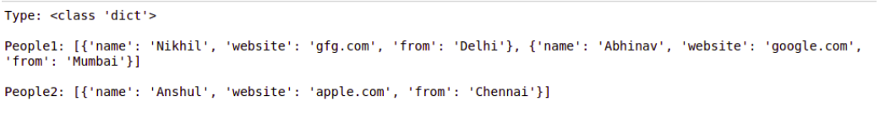

* **Convert JSON String to dictionary in python**

**Code:**

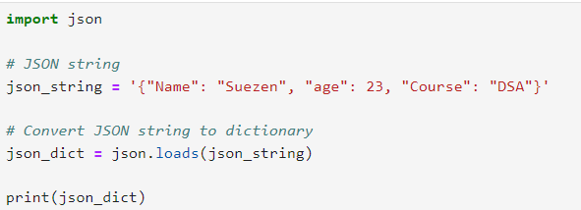

**Output:**



* **Writing a JSON to a file in python using json.dumps()**

**Code:**

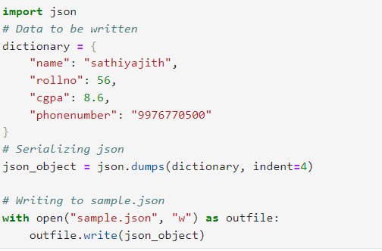

**Output:**

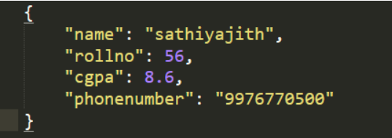

* **Writing a JSON to a file in python using json.dump()**

**Code:**

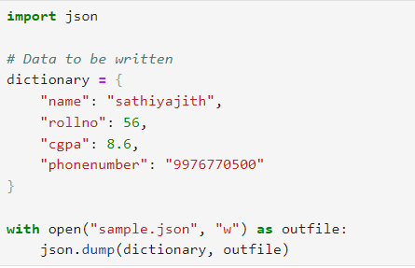

**Output:**



* **Reading a JSON file using json.load()**

**Code:**

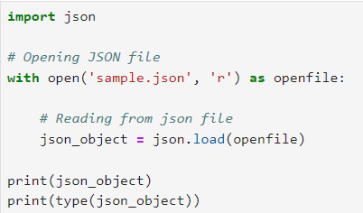

**Output:**



**Question: Get Unique values from a list**

* **Getting unique values from a list using set method**

**Code:**

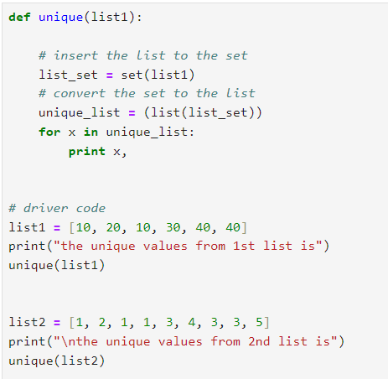

**Output:**

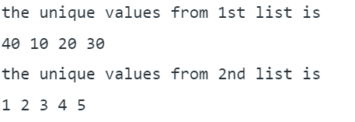

* **Using reduce() function**

**Code:**

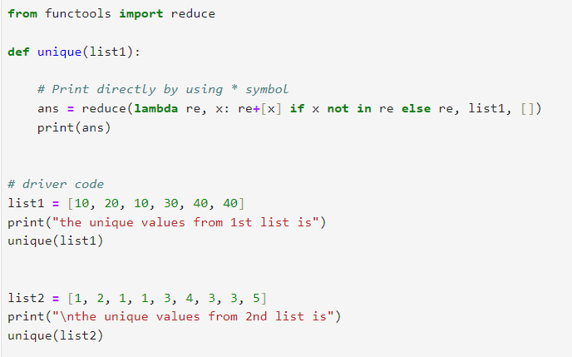

**Output:**

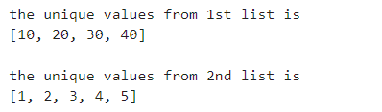

* **Using operator.countof() method**

**Code:**

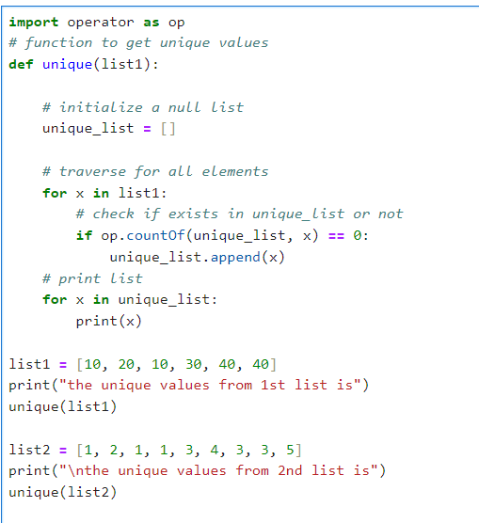

**Output:**

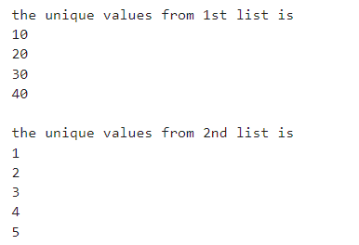

* **Using numpy.unique**

**Code:**

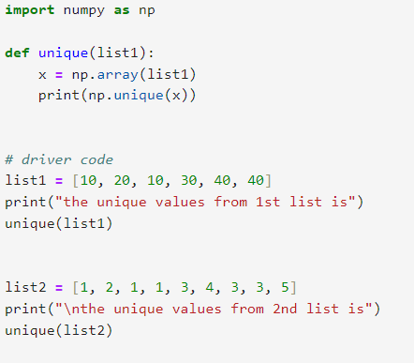

**Output:**

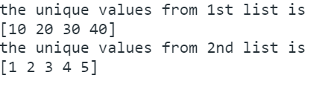

**Question: Python Sorting**

**Code:**

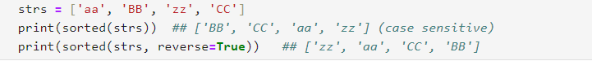

**Output:**



* **Custom sorting with key =**

**Code:**

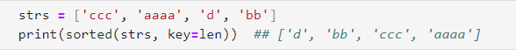

**Output:**

